Rheology of Self Compacting concrete with Marble Powder mixes in comparison to Fly ash and Sand Based Mixes

Anuj¹, Miss Meera¹ and Supratic Gupta²
¹ Doctoral Student, Department of Civil Engineering, IIT Delhi, India
² Assistant Professor, Department of Civil Engineering, IIT Delhi, India
(Corresponding Author: Supratic@civil.iitd.ac.in)
___________________________________________________________________________
Abstract
Marble powder is available in various parts of the world abundantly as there is a great demand of marble stones. The particle size of these material are marginally courser compared to cement and fly ash. Detailed experimental study has shown that with proper water correction, strength is not compromised. In this study, results of an experimental study to show the possibility of use of marble powder in self-compacting concrete (SCC), in comparison to Fly Ash based and Sand Based SCC Mixes. Here, flow, T500, V funnel time and Viscosity by BT2 Rheometer have been presented. It clearly shows that Marble powder can be used in SCC.
Key words: Rheology, workability, particle size, compressive strength

- Introduction
Self-Compacting Concrete (SCC) is a concrete that can be placed and compacted under its own weight, without requiring any consolidation, and which assures complete filling of formwork. In order to achieve this performance, the fresh concrete must have both high fluidity and stable homogeneity [1]. The stability of SCC can be improved by incorporating fine inert material which may be either pozzolanic materials or inert.
Marble powder is available in various parts of the world abundantly as there is a great demand of marble stones. The particle size of these material are marginally coarser compared to cement and fly ash. Detailed experimental study has shown that with proper water correction, strength is not compromised [2]. In this study, results of an experimental investigation to show the possibility of use of marble powder in self-compacting concrete (SCC), in comparison to Fly Ash based and Sand Based SCC Mixes. Here, flow, T500, V funnel time and Viscosity by BT2 Rheometer have been presented. It clearly shows that Marble powder can be used in SCC.

- Literature Review
2.1 SCC and marble powder
As per the EFNARC [1], a self-compacting concrete is qualified only when all the three parameters namely flowing ability, passing ability and segregation resistance are qualified. It has also been reported that in highly workable concrete by increasing fines, segregation can controlled and also enhanced cohesiveness and viscosity [3]. Topcu[4] reported that replacing cement and fly ash with marble dust improves the rheological properties of self-compacting concrete ignoring strength. It has also been reported that particles with an irregular shape of marble powder cause a shear thickening behaviour and, therefore, an increase of the viscosity [5, 6]. Similar results were reported by Beladi[7] and Alyamac [8]. In most of these work, comparison is rarely done keeping strength constant.
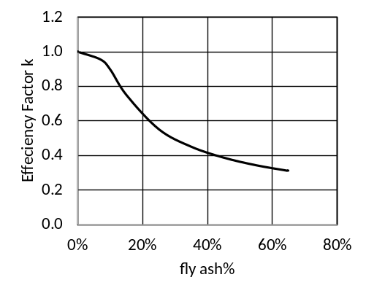
Fig. 1: Efficiency Factor of Fly ash[9] [10]

2.2 Strength prediction for fly ash concrete
Compressive strength prediction of concrete incorporating fly ash can be predicted using an efficiency factor $k=f\left(\frac{f}{c+f}\right)$ as function of fly ash percentage (Fig. 1) [9] [10] as in Eq. 1 for OPC 53 grade. Anuj had shown that marble powder can be used in concrete in significant quantity till without compromising in the strength provided water correction is done appropriately [2]. This is possible till total powder content is about 600 kg/m3 for cement, fly ash and marble powder combination. Micro silica increases cohesivity. c, w, f are Cement, Water and Fly ash in Kg/m³
Strength =$f\left(\frac{w}{c+kf}\right)=13.5*{\left(\frac{w}{c+kf}\right)}^{-1.35}$ (1)

- Materials
For the purposes of the current study, fly ash and marble powder was used. The chemical analysis as well as the physical properties of fly ash and marble powder are shown in Table 1. 53 Grade OPC cement (c) was used for the production of all SCC mixtures. It is noticeable that fly ash and marble powder present similar grading, which are similar to cement. The particle size distribution curve of all the fine are shown in Fig. 2. Fig. 32 shows the magnified SEM picture of Marble Powder. It is irregular in shape. Potable water (w) and polycarboxylic ether superplasticizer (PCE) were used in all mixtures.
Table 1. Chemical analysis (% m/m) and Physical properties of fly ash and marble powder
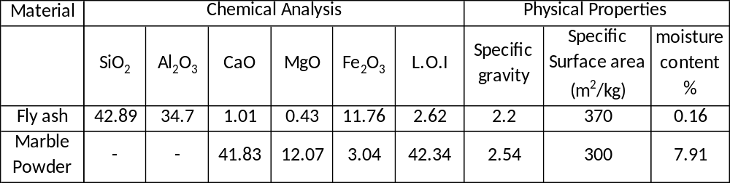

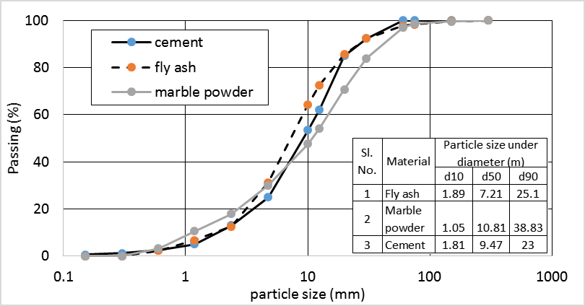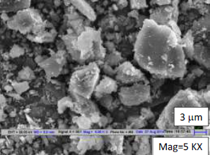
Fig 2: Particle size distribution of fine materials Fig. 3: SEM Picture of Marble Powder.
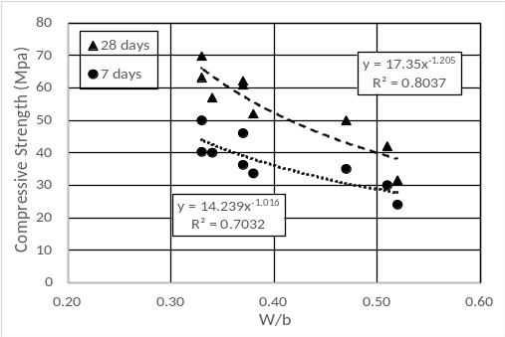
Fig. 4: compressive strength vs w/b
- Mixes, Results and Discussion
In order to investigate the rheology properties of Self compacting concrete, nine SCC mixtures were adopted. Three of higher content of coarse aggregate mixes (i.e. G1-S, G3-S and G4-S) and three of higher fly ash mixes (i.e. G1-F, G3-F, G4-F) and three of marble powder mixes (i.e. G1-M, G3-M, G4-M) were casted and tested. In all mixes fly ash was used. Suitable dosages of polycarboxylic ether superplasticizer, were used to all mixtures, in order to reach the required fluidity. Self-compacting mixes were designed incorporating marble and granite powders ensuring a maximum usage of the same especially as powder material for different w/b ratios varying from 0.52 to 0.33. Marble powder is put in water to make soft paste (Fig. 3a). Water correction for both sand and marble powder is done. For the production of the concrete mixtures a fixed-pan type mixer with rotating blades was used and the same mixing procedure was carefully followed for all mixtures. At first, the aggregates were dry-mixed. Then, the fly and cement was added and all ingredients were further dry-mixed. Marble powder paste was add in mixes containing marble powder. Then, 80% of the total water content was added, followed by the rest 20% of the water, in addition with the super plasticizer. Slump-flow, T500, V Funnel and Viscosity by BT2 Rheometer is measured. The mixtures were rheologically classified according to the provisions of the European Guidelines EFNARC for SCC [1].
Table 3: Mix proportions Kg/m³
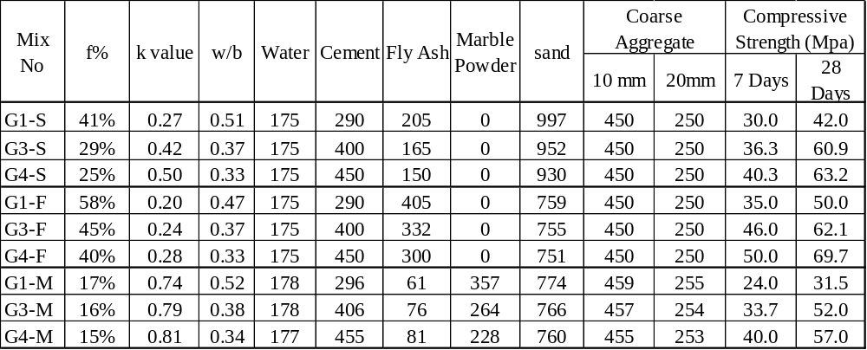

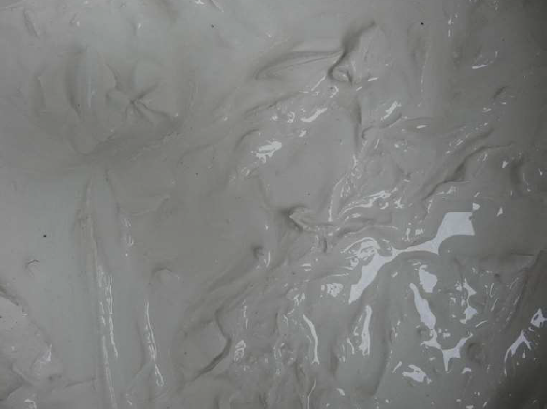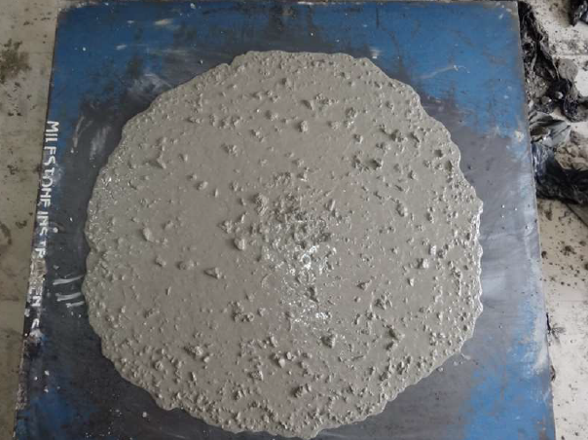
(a) marble powder paste (b) SSC at flow of 690mm
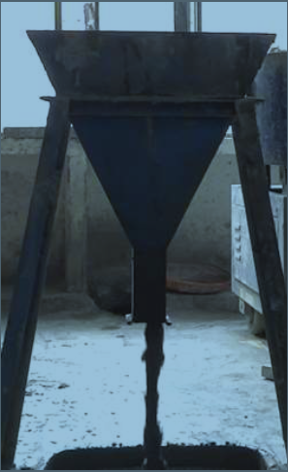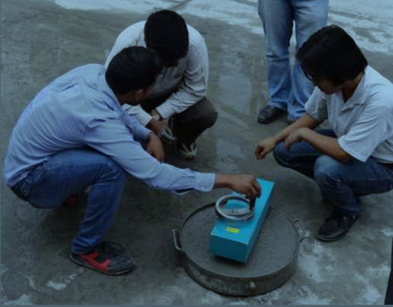
(c) V-funnel test (d) BT-2 Rheometer test
Figure 5. Rheology test set up
In order to understand the rheological behaviour of the concrete, admixture was added in increasing quantum in each of the mixes to reflect at least three to four points of different flow values. For each flow value in each of the mixes, T₅₀₀, and V_{ft} were measured. Critical yield stress and coefficient of viscosity values obtained by using BT2 rheometer were recorded and the results are reproduced in Table 4.
The EFNARC [1] guidelines for SCC provide consistence classification of self-compacting concrete in terms of flow, viscosity, passing ability and segregation resistance of the mix shown in Table 5(b). It mentions three flow classes namely SF1 (550 mm – 650 mm), SF2 (660 mm –750 mm) and SF3 (760 mm – 850 mm) ,depending on the type of structure and congestion of reinforcement. Viscosity of the mix can be assessed by either T₅₀₀ or the V_{ft}. The mix should have optimum balance of flow and viscosity. Table 5(b) shows that most of mixes fall under the VS2/VF1 or VS2/VF2 category of EFNARC. It is obvious that mixing of marble powder provides better SCC mixes. To gain maximum efficiency it is acceptable if we use minimum10-15% fly ash and use marble powder to get extra powder content. The consistence parameters like flow, T₅₀₀, V_{ft}, viscosity for different mixes were analysed. The relationship between T₅₀₀, V_{ft} and viscosity in Fig. 6 were found to be linear.
Table 4: Rheological properties of marble powder, fly ash and higher sand concrete
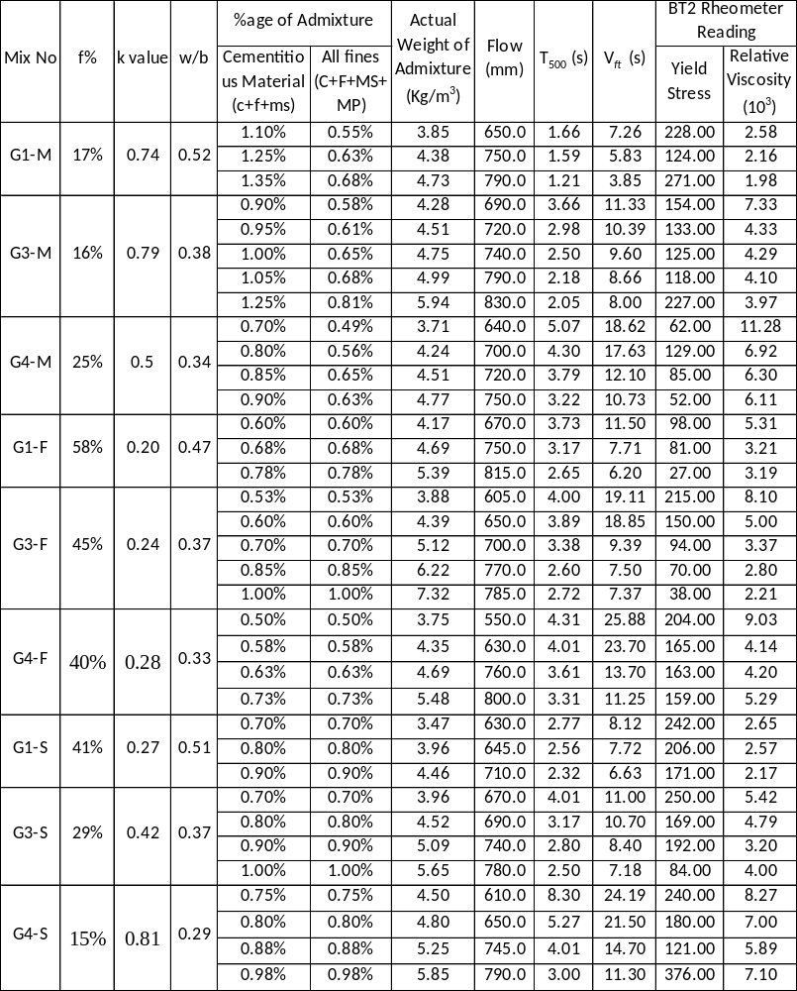

Conclusion
This paper presented a study of rheological properties of self-compacting concrete using fly ash based, sand based and marble powder based design. The following conclusion can be drawn:
- Marble powder has particle size in similar range of cement and fly ash. It is slightly coarser and irregular in shape.
- The relationship between T₅₀₀, V_{ft} and viscosity by BT2 rheometer are linear.
- Marble powder usage provided better mix complying with EFNARC specifications better.
References
Table 5(a). EFNARC limits for three groups of SCC
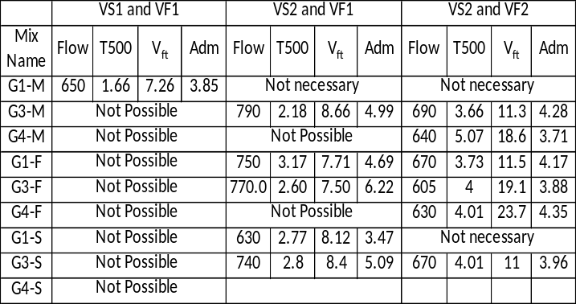
- European guidelines for self-compacting concrete: specification. Production and use (EFNARC) May 2005
Table 5(b). EFNARC [1] for SCC
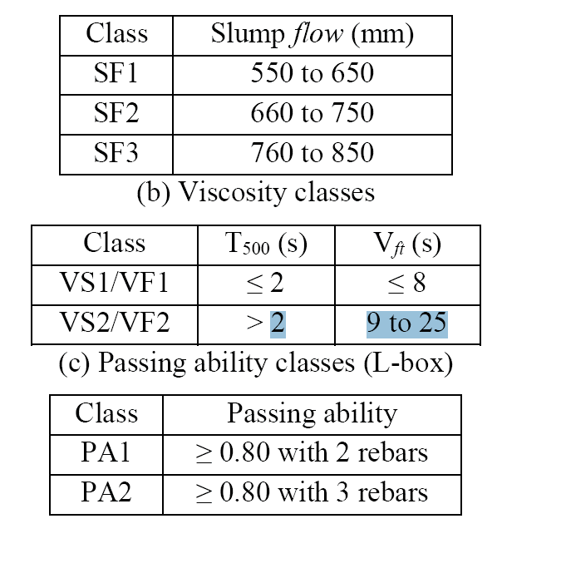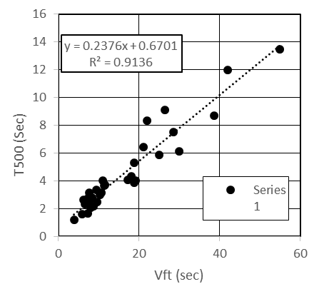
Figure 3: T₅₀₀ vs. V_{ft} for SCC mixes
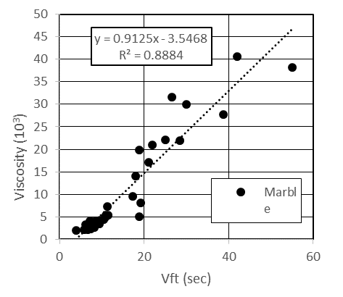
Fig. 6: Viscosity vs. V_{ft} for SCC mixes
- Anuj, Utilization of Marble and granite powder as green building materials in concrete, PhD Thesis, IIT Delhi
- Okamura H., Ozawa K., and Ouchi M. Self-compacting concrete. Structural Concrete, Vol. 1, No. 1, March 2000, pp. 3-17.
- Topcu I. B., Bilir T., and Uygunoglu T. Effect of waste marble dust content as filler on properties of self-compacting concrete. Construction and Building Materials, 2008, pp. 1-7.
- Cyr. M, Legrand. C., Mouret, M., Study of the shear thickening effect of superplasticizers on the rheological behaviour of cement pastes containing or not mineral additives, Construction and Building Materials, 30 (9) (2000), pp. 1477–1483
- Gallias, J. L., Kara-Ali, R., Bigas, J. P., The effect of fine mineral admixtures on water requirement of cement pastes, Construction and Building Materials, 30 (10) (2000), pp. 1543–1549
- Belaidi, Azzouz L., Kadri E., and Kenai S., Effect of natural pozzolana and marble powder on the properties of self-compacting concrete. Construction and Building Material, 31. 2012, pp. 251-257
- Alyamac K.E .and Ince R. A preliminary concrete mix design for SCC with marble powder. Construction and Building Materials, 23, 2009, pp. 1201-1210
- Khuito M., Gupta Supratic, Evaluating the efficiency factor of fly ash for predicting compressive strength of fly ash concrete, , Structural Engineering Convention 2014, 9th Biennial Event. New Delhi, India, 22–24 December 2014. New Delhi: Indian Association for Structural Engineering (IASE)
- Pusa V. Study on mechanical properties of concrete with respect to fly ash, M. Tech Thesis, Civil Engineering Department, IIT Delhi, 2011.

