Template for RoBM-Proceedings (AAA-Titel)

John Sampleman¹, Paul Pattern² (AAA-Autoren)

¹ Institute of Pattern-Research, Town, Spain (AAA-Institution)
² Research Institute, Exampletown, Graceland (AAA-Institution)

Abstract (AAA-Überschrift1)
This file (.dot) contains guidelines for writing your contributes to the RoBM-Proceedings. It contains essential definitions for a uniform design of the submitted contributions. There is also available a version for LibreOffice. Compliance of these regulations relieves the work of redaction and summarizing. It moreover contributes to a continuous consistent design of these proceedings, like a book usually should have.
The appearance of this document was generated by the described templates. You simply have to assign the predefined templates to the mentioned paragraphs. This document follows these format guidelines. In the appendix you may find the template-definitions in plain language for transfer into other word processing programs if necessary. A window with the predefined templates of us you may get in MS-Word by typing “Alt+Ctrl+Shift+S” and in LibreOffice by clicking on menu “Format Styles and Formatting”. (AAA-Standard)
1 Introduction (AAA-Überschrift1)
This Microsoft Word template serves as a guide to creating the RoBM-Proceedings with a consistent book layout. It thus contains paragraph template definitions that are indispensable when writing your script for the RoBM-Proceedings. You can write your manuscript directly into this guideline. Though use the predefined format-templates "AAA-Standard", "AAA-Titel" and so on. Please use only format-templates starting with triple A. The labels of the used format-templates are written at each end of a paragraph in this document in brackets in italics. If you want to use another word processing program, you can find the labels and the definitions of each paragraph template in plain language in the appendix. These settings can be transfered into your own word processing program analogously. (AAA-Standard)
2 Page Layout (AAA-Überschrift1)
Please define your document in DIN A4 format. The manuscript will be scaled down to DIN A5 in the book. (AAA-Standard)
Please do not define own page numbers. (AAA-Standard)
2.1 Page Layout and Margins (AAA-Überschrift2)
To define the margins, please select in the menu Format/Page the following settings. (AAA-Standard)
- Format paper size: A4 (AAA-AufzählungPunkt)
- Margins: (AAA-AufzählungPunkt)
- Top 2.75 cm, right (outer) 2 cm, bottom 2.75 cm, left (inner) 3cm, gutter margin 0 cm, (AAA-AufzählungPunkt)
- Header and footer: margin 1.75 cm
(AAA-AufzählungPunkt)
- Page Layout mirrored, to invert margins on even and odd pages.
(AAA-AufzählungPunkt)
- Header and footer: even and odd pages mirrored. (AAA-AufzählungPunkt)
2.2 Enumerated Paragraphs (AAA-Überschrift2)
- This enumeration continues automatically... (AAA-AufzählungZahl)
- … if a new paragraph starts. So in paragraphs containing longer lines a pretty make-up will be generated. In the printed book it will look in the same manner. (AAA-AufzählungZahl)
2.3 Paragraph Templates (AAA-Überschrift2)
The template labels for the paragraphs can be found in this document at the end of every paragraph. They are written in italics. Every name starts with „AAA“ and will appear on top of the list of the paragraph templates in MS-Word or LibreOffice, if put in alphabetical order. The definition of the paragraph templates (typeface, size, row pitch, alignment etc) can be found in the appendix. (AAA-Standard)
3 Requirements to Certain Elements of Your Manuscript (AAA-Überschrift1)
3.1 Graphic/Photos (AAA-Überschrift2)
Graphics, photos and charts must be camera-ready. They should be in the desired size and position in the manuscript. The resolution of photos and graphics should not be more than 600 dpi. Please insert graphics as vector graphics if possible as SVG (Scalable Vector Graphics) or in EPS-Format (Encapsulated PostScript) including preview and fonts or Windows-Meta-Data. Avoid OLE-Objects. Pixel files can be inserted as uncompressed TIFF-format.

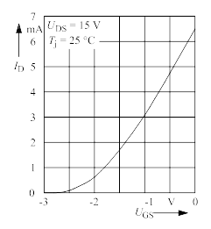
(AAA-Bild)
Figure 1: Example of a multiline caption with corrected indention and make-up under a centered graphic. (AAA-Bildtext)
The Proceedings will be printed in black and white. Thus colored images/graphics should be inserted as monochromatic or gray scale images/graphics.
Be aware that your manuscript will be scaled down to 71 percent. Thus avoid line-width less than 0.3 mm and type-size less than 10 pt.
(AAA-Bild)
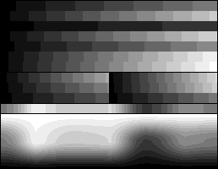
Picture 2: Example of a rasterized image (AAA-Bildtext)
3.2 Tables
The following table serves as a reference. Solely the font-type should resemble that of the continuous text (Times/Times New Roman). The caption of the table, just like that of pictures, should be put below the table and has to be formatted consistently ["AAA-TabellenBeschriftung"]. The table should be aligned to the center. Other than that it can be formatted individually.

Table 1: Information on recipes and the tools (according to Grandma 2016) (AAA-TabellenBeschriftung)
 | Ingredients |  |  | Tools
Mountain  Donuts | kg | Type | Note | Extra sharp knife | Cutting board
Vegetables  onion  celery | 2  4 | specialª  normal | none  green | 25  10 | 10 x 20 cm  15 x 25 cm
Meat  beef  pork | 2  4 | Argentinian  Polish^{c} | dry-aged  fresh | 311  clean first! | 28 x 13 cm  0.5 cm
ªcooking spoon and salad
^{b}onions, leek and tomato
^{c}can as well be served at special occasions if there is enough time for preparation
3.3 Formulas
Formulas are centered using tabulators. The numbering of formulas should be right-aligned. You easily can click on the formula below, copy, mark and edit it. This way typefaces, and sizes are automatically correct. There are lots of manuals, how to use formula-editors. Below you find the proper settings for older versions of MS-Word.
(1)
(AAA-Formel)
Following Pictures show the settings of the formula-editor of MS-Word 3-5:
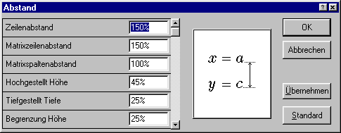
Picture 3: Settings format and spaces to standard.(AAA-Bildtext)
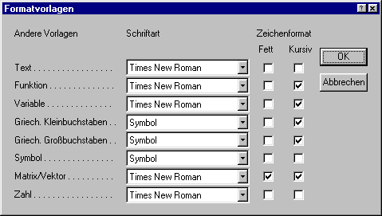
Picture 4: Settings of paragraph template in the formula editor. (AAA-Bildtext)
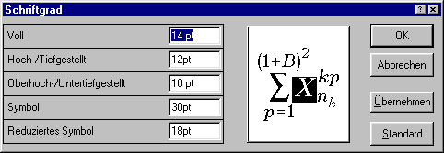
Picture 5: Settings of type sizes in the formula editor. (AAA-Bildtext)
4 Generating the Digital Version of Your Manuscript
The script should be transmitted digitally. It has to be formated into a „MS Word"-file (file extension *.doc) or into a LibreOffice/OpenOffice-file (file extension *.odt). To prevent potential problems with other softwares, all graphics(*.wmf, *.svg)/pictures(*.tif, *.eps)/charts(*.wmf, *.tif, *.eps, *.svg) should be saved separately and in the desired size. EPS-files should be saved under the following setting: Encapsulated PostScript, Level 2, including a preview and all fonts.
Please send us your complete manuscript as PDF-file, in order that we will be able to examine the layout we will generate.
5 Transmission of Your Manuscript
In addition to the PDF-file, please send us the digital version of the script via e-mail to info@schleibinger.com. In case of further questions do not hesitate to contact us.
6 Acknowledgements
This guideline is based to a large extent on a proceedings-template of AHMT (Arbeitskreis der Hochschullehrer für Messtechnik e.V.). We only extended it a little bit and translated it.
Bibliography
Please insert citations at the end of the document as shown below. This is independent of using footnotes in MS-Word or LibreOffice as shown on page 1.
[1] Surname, Given Name; Surname, Given Name: Title, Place: Publisher, Year (AAA-Literatur)
[2] Surname, Given Name: Title of the Article, Journal or Proceedings, Pages, Surname, Given Name of the Editor, Place: Publisher, Year (AAA-Literatur)
Appendix
Please note: Never use font sizes in your document that are as small as the following.
Definition der Formatvorlagen in MS Word
Standard (Ausgangsbasis von Word, bitte keinem Absatz zuweisen)
Schriftart: Times New Roman, 10 pt, Deutsch (Deutschland), Linksbündig, Zeilenabstand einfach, Absatzkontrolle
AAA-Titel (Titel des Manuskriptes)
AAA-Standard + Schriftart: Arial, 18 pt, Fett, Zentriert, Abstand Vor 0 pt, Ebene 1
AAA-Autoren (Vorname, Name der Autoren)
AAA-Standard + Schriftart: Arial, 12 pt, Zentriert, Zeilenabstand einfach
AAA-Institution (Uni, Prof., Ort, Tel., e-mail )
AAA-Autoren +
AAA-Standard (Normaler Fließtext)
Standard + Schriftart: 14 pt, Block, Zeilenabstand mehrere 1,2 ze, Abstand Vor 12 pt, Tabstopps bei: 1 cm, 2 cm, 3 cm, 4 cm, 5 cm, 6 cm, 7 cm, 8 cm, 9 cm, 10 cm, 11 cm, 12 cm, 13 cm, 14 cm, 15 cm, 16 cm
AAA-AufzählungPunkt (Aufzählung mit Aufzählungszeichen)
AAA-AufzählungZahl (Aufzählung mit vorangestellten Zahlen)
AAA-Standard + Einzug: Links 0,75 cm Hängend 0,75 cm, Aufzählungszeichen, Tabstopps bei: 1,5 cm, Nicht an 1 cm
AAA-Bild (Bild, Diagramm,Grafik,Foto)
Formatvorlage des nächsten Absatzes: AAA-Bildtext
AAA-Standard + Schriftart: Arial, 10 pt, Zentriert, Abstand Vor 18 pt, Absätze nicht trennen
AAA-Bildtext (Bildunterschrift)
Formatvorlage des nächsten Absatzes: AAA-Standard
AAA-Standard + Schriftart: 12 pt, Einzug: Links 1 cm Hängend 1,5 cm, Abstand Nach 12 pt, Linksbündig, Tabstopps bei: Nicht an 1 cm, 2 cm
AAA-Formel (Formeln mit Nummer)
Formatvorlage des nächsten Absatzes: AAA-Standard
AAA-Standard + Tabstopps bei: 8 cm Zentriert, 16 cm Rechtsbündig, Nicht an 1 cm, 2 cm, 3 cm, 4 cm, 5 cm, 6 cm, 7 cm, 9 cm, 10 cm, 11 cm, 12 cm, 13 cm, 14 cm, 15 cm
AAA-Fußnote (Fußnote)
AAA-Standard + Schriftart: 12 pt, Einzug: Hängend 1 cm, Zeilenabstand einfach, Abstand Vor:0
AAA-Literatur (Quellenangaben)
AAA-Standard + Einzug: Hängend 1 cm, Zeilenabstand einfach, Abstand Vor 8 pt, Tabstopps bei: Nicht an 1 cm, 2 cm, 3 cm
AAA-Tabellentext (Tabellenunterschrift)
Formatvorlage des nächsten Absatzes: AAA-Standard
AAA-Bildtext + Einzug: Links 1 cm Hängend 2,25 cm, Zeilen nicht trennen, Tabstopps bei: Nicht an 3 cm
AAA-Überschrift 1 (Überschrift 1. Ebene des Manuskripts)
Formatvorlage des nächsten Absatzes: AAA-Standard
AAA-Standard + Schriftart: Arial, 16 pt, Fett, Einzug: Hängend 0,75 cm Linksbündig, Abstand Vor 32 pt, Absätze nicht trennen, Zeilen nicht trennen, Ebene 2, Tabstopps bei: 0,75 cm, Nicht an 1 cm, 2 cm, 3 cm, 4 cm, 5 cm, 6 cm, 7 cm, 8 cm, 9 ...
AAA-Überschrift 2 (Überschrift 2. Ebene des Manuskripts)
Formatvorlage des nächsten Absatzes: AAA-Standard
AAA-Überschrift 1 + Schriftart: 14 pt, Einzug: Hängend 1,25 cm, Abstand Vor 28 pt, Ebene 3, Tabstopps bei: 1,25 cm, Nicht an 0,75 cm
AAA-Überschrift 3 (Überschrift 3. Ebene des Manuskripts)
Formatvorlage des nächsten Absatzes: AAA-Standard
AAA-Überschrift 1 + Schriftart: 14 pt, Einzug: Links 0 cm Erste 0 cm, Abstand Vor 24 pt, Ebene 4

